Assessing our Learners

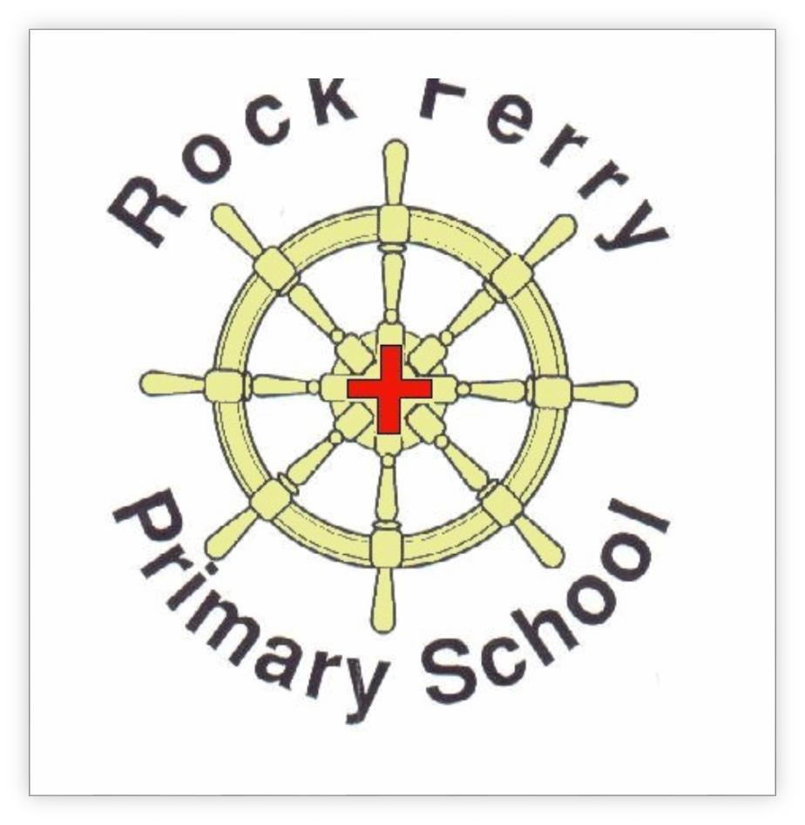

Rock Ferry Primary School
Assessment Policy

SEPTEMBER 2019

Review Date October 2019 Signed …………............................

ASSESSMENT OCTOBER 2016 \\SCHOOL.LOCAL\FOLDER REDIRECTION\OFFICE DESKTOP\JHENRIKSEN\DESKTOP\ASSESSING OUR LEARNERS ASSESSMENT POLICY 2016. FINAL.DOCX

Rock Ferry Primary Philosophy of learning
At Rock Ferry Primary School we have a mastery approach to learning. This means we encourage our pupils to develop a “growth mindset approach” to life and learning to help them towards achieving age related expectations. We ensure that with outstanding strategies, appropriate resources to support and access learning, hard work and a “can do” attitude they will achieve in all areas of the curriculum and experience the “buzz” of exciting, challenging learning every day. With this approach in mind, we will give our pupils a landscape for learning that responds to their needs, not a ladder to climb; we understand that mastery can be achieved by all learners in different ways and in different areas of the curriculum. We want pupils to acquire the basic skills necessary for life, but at the same time hope that through the experiences we give them, they will find an area that sings to them and inspires them to achieve mastery either now or in the future.

Our curriculum - Providing our pupils with a mastery curriculum of skills, knowledge and understanding
We agree with The Commission on Assessment without levels (September 2015) who define offering a mastery curriculum as:
- Learning broken down into discrete units and presented in logical order
- Something that every child can aspire to and every teacher should promote
- All pupils having access to the whole curriculum
- Differentiation offered through support and challenge to promote depth of learning
- A deeper understanding of fewer topics, through problem solving, questioning and encouraging deeper thinking.
(CoA without levels September 2015)

As a school we are committed to this definition and aim to provide a broad, balanced and creative curriculum firmly rooted within engaging and challenging contexts for learning. Our curriculum aims to develop the mind, body and soul of all of our pupils.
Curriculum Intent
As a whole staff, we have explored and developed our own definition of the term “mastery” of learning within a subject. We believe it to mean:

“The confident, consistent and fluent application of skills, knowledge and/or understanding across a range of contexts”
RFPS staff April 2016

Ways in which we will be able to identify whether our pupils are masters of their learning will include the ability to:
- Describe it in their own words
- Represent it in a variety of ways
- Explain it to someone else
- Make up their own examples (and non-examples)
- See connections between their learning and other facts/ideas as well as skills learnt
- Recognise it in new situations or contexts
- Make use of it in various ways, including new situations
- Look but also see
- Listen but also hear
- Build skills and knowledge in a cohesive, progressive manner.

The Principles of Assessment and Assessing children’s progress towards mastery in Rock Ferry Primary School.

Principles of Assessment
At Rock Ferry Primary School, we believe that assessment is at the core of all learning. Our approach to assessment is based upon the following 5 principles.
Principle 1
Assessment puts the child at the centre of their learning.

Principle 2
Assessment is honest, fair and consistent and compares results to both local and national standards.
Principle 3
Daily assessment is at the heart of outstanding teaching, which leads to outstanding learning, which leads to outstanding progress.
Principle 4
Assessment provides feedback which recognizes effort and suggests next steps towards deep and meaningful learning.
Principle 5
Assessment is focused on outcomes for children within and beyond the school day in partnership with parents and carers.

What our Assessment Principles and systems look like in practice
Our assessment system comprises of 3 main elements and ensures that all practice falls in line with our principles.
  - Ongoing formative assessment
    - higher order questioning
    - effective marking, feedback and pupil response time – which will include a range of approaches and systems (see appendix 2)
    - guided work observations and observational assessments
    - adjustment of planning /teaching based on assessments
    - The confidence that all pupils can improve.
    - Use of Balance to both self-assess and teacher assess daily learning and identify next steps for all groups of children
    - Use of whole class feedback sheets to celebrate success, reflect upon and review learning, and pose questions
    - Daily/weekly quizzes and assessments (see Appendix 1) to consolidate learning

  - In house summative assessment
    - termly/ annual tests to inform summative judgements and provide gap analysis
    - end of unit /subject assessments
    - pre/post assessments for Wave 2/3 interventions
    - growth mindset questionnaires
    - EYFS termly assessments
    - Book scrutinies

  - External summative/nationally standardised assessment

    - NC end of KS2 tests
    - NC end of KS1 teacher assessment
    - Y1 phonic screening (including Y2 re-takes)
    - EYFS – baseline assessments
    - Y4 times table check (MTC)
    - Standardisation and moderation – internal and external

No single kind of data mechanism or analysis can tell the whole story about a school or its pupils. In Rock Ferry Primary School in you will see, hear and feel our principles in action through:

Principle | What it looks like in practice
Assessment puts the child at the centre of their learning | Planning that starts with the child and looks at next steps for learning.  Differentiation in planning and task design.  Sharing targets with children.  A range of feedback techniques, verbal written and peer (see Appendix 2).

Use of Assessment for Learning
Strategies that allow the children to take ownership of their learning- e.g. clear success criteria
A growth mindset approach to learning-children being confident to enjoy challenge and take risks.
2. Assessment is honest, fair and consistent and compares results to both local and national standards. | Starting with where the child is.  Consistent use of formative and summative assessments to identify school, cohort and individual gaps.  Reflection through regular pupil progress meetings.  Discussions with the child, teacher and parents.  Internal and external moderation. Internal monitoring.  Targets set internally and monitored against local and national data.  A school improvement plan that reflects the needs of the school but uses local and national data as benchmarks.  Honest and aspirational school self - evaluation
3. Daily Assessment is at the heart of outstanding teaching, which leads to outstanding learning which leads to outstanding progress. | Whole school, consistent approach to assessment – including the use of Balance.  Ongoing reflection, CPD and discussion amongst staff.  Use of AfL techniques built into daily planning and teaching.  Open ended questioning techniques that allow the children to justify and explain thinking.  Use of a range of feedback techniques that identify next steps to children and teachers.

Flexibility in planning and delivery that allows lessons to be adapted and reshaped to respond to pupils’ needs.
Effective use of in house formative /summative assessment tools (Target Tracker and Balance) to allow teachers to track progress accurately.
Use of a range of teaching models (collaborative, cognitive etc).
Performance management is used successfully to allow staff to identify their own development needs.
4. Assessment provides feedback which recognizes effort and suggests next steps. | A broad curriculum based on a mastery approach.  Use of agreed feedback techniques both verbal and written (see Appendix 2).  Staff who follow the Feedback policy.  Use of internal tracking to identify gaps and next steps.  Children who know their own next steps.  Open ended contexts that encourage a positive, ‘can-do’ approach to learning.  Celebration of effort and success in assemblies etc.
5, Assessment is focused on outcomes for pupils within and beyond the school day in partnership with parents and carers. | House system based on good role models.  Links with community through visitors that provide good role models and aspiration for pupils- e.g. Olympic Athletes.  Use of Learning Heroes in classrooms to celebrate character.  Clubs that allow pupils to learn a range of skills.  Home learning tasks that are purposeful and involve parents.

Regular workshops for parents and carers to discuss progress and share children’s learning.
Use of ICT based programmes such as LbQ, Times Tables Rock Stars and Spelling Shed that allow children to access learning at home.
Courses for parents to allow them to develop as learners.
Celebration of pupils achievements in school and out through assemblies, meetings and Class Dojo.

USE OF BALANCE AND TARGET TRACKER WITHIN FORMATIVE AND SUMMATIVE ASSESSMENT
The national curriculum (NC 14) has set out clear expectations about what children should achieve by the end of each key stage, and for English, maths and science gives clear guidance about when (year group/phase) this content should be covered.
For making daily and weekly assessments, tracking and analysing pupils’ attainment and progress against NC programmes of study and for helping to set next steps, yearly and end of key stage targets we currently use Balance and Target Tracker.
The Balance number coded assessment system is based on a mastery model and is aligned to our own definition.
When deciding where to assess pupil’s progress towards the “mastery” of a concept or skill set against age related NC statements, we make number based judgements to demonstrate where in their journey our children currently sit.
Mastery at RFPS is defined as: “The confident, consistent and fluent application of skills, knowledge and/or understanding across a range of contexts”

Balance Number | Learning Level | The learner is | What it looks like in practice
1-3 | Not begun | Unconsciously incompetent | Curriculum content not taught  Knowledge, skills and understanding not at all developed
4-6 | Working towards | Consciously incompetent | On the surface, the curriculum is being dipped into

 | Shallow  Level learning |  | Knowledge, understanding and skills are developing and are unlikely to be remembered at this stage  Confidence is growing  Reinforcement may be required from another person or through a variety of related approaches and activities
7-9 | Achieved Deep level | Consciously competent | Curriculum content has depth of knowledge, understanding and skills and is developed  Confidence is secure  Similar tasks can be completed successfully and  independently
Secure Lock | Mastered  Mastery Level | Unconsciously Competent | Curriculum content has been explored in a variety of contexts so that the full depth and breadth has been mastered and connections can be made  Knowledge, understanding and skills are embedded and can be transferred to different contexts and subjects or to another person with absolute independence  Skill sets and knowledge banks are tapped into purposefully to match a variety of tasks over time

Pupils that are working above their age related expectation will be assessed against the “Working Deeper” Balance objectives. These objectives will be assessed using the same scale as above.
- These ongoing judgements are made using a wide range of formative assessment tools and with assessment of learning, and for learning, at their core.
- On a termly basis, staff make a summative assessment of pupil’s learning against age related expectations using Balance criteria and terminology. (See appendix) and record their judgement onto Target Tracker (to be updated when Balance has this facility)
- Staff meet with SLT on a termly, sometimes half termly, basis for pupil progress meetings where the data is analysed and used to:

- Track pupil attainment and progress at school, cohort and individual levels.
- Identify which groups/individuals’ progress need to be accelerated.

- Discuss and identify gaps and the implications on provision, planning and quality first teaching
- Identify next steps and share targets with pupils
- Compare current attainment and progress with local and national counterparts
- Ensure the school is on track and doing everything possible to meet national attainment and progress measures.
- Analyse and track the gap in attainment and progress for disadvantaged pupils, decide if it is closing and take steps to address any issues identified and ensure national curriculum coverage and progression is evident.

“Formative assessment describes the process of teaching and learning, whereas summative assessment takes place after the teaching and learning”
Shirley Clarke

These systems give us a tool to measure progress, however we will be more concerned in using it as part of a range of mechanisms that demonstrate progress towards mastery, rather than just measure it.

All staff have a part to play in all parts of the assessment cycle but we have identified the following defined roles and responsibilities when making assessments at each level:

ROLES AND RESPOSIBILITIES

    - Teachers are responsible for ensuring that they are familiar with standards (internal and national) for their subjects.
    - All teachers are responsible for using a range of formative and summative assessment mechanisms to assess, track and demonstrate progress.
    - Teachers use this information to provide appropriate learning challenge and next steps in learning for all pupils.
    - Subject leaders are responsible for ensuring that assessments are carried out accurately and to deadlines
    - Senior leaders are responsible for ensuring that staff are sufficiently trained, subject leaders are monitoring quality and accuracy, and tracking data agrees with outcomes in formal assessments

    - The Governing Board are responsible for providing challenge and for holding the HT and SLT to account for the outcomes of our learners.
    - Parents are responsible for working in partnership with the school and in supporting the school’s ethos and policy towards learning through regular communication and interaction with staff and children.
    - They are responsible for providing a secure home environment which allows their children to flourish academically, emotionally and socially and come into school ready for learning.

How the Governing Board holds the school to account
Definitions of Government Floor Standards and Coasting Standards are shared with governors annually.
The HT meets with the Chair of Governors on a termly basis to share current progress and attainment and show how the school is ensuring that it is working towards reaching current floor standards and improving outcomes.
HT’s Report to Governors gives a termly standards update. A more detailed one is shared at the Achievement Committee Meeting.
In September a special Standards Governors’ Meeting is held to share national test results and implications. The DfE Analysing Pupil Performance information is shared when received and this information is used to form the basis of the School Improvement Plan.

E. ENSURING HARMONY BETWEEN ASSESSMENT AND LEARNING
As teachers, we have a great opportunity to change lives, to influence. It is part of our job to give every child we work with not just a love of learning, but also a love of learning that lasts a lifetime.
Assessment for learning is any assessment for which the first priority in its design and practice is to serve the purpose of promoting pupil’s learning. This is our core purpose at Rock Ferry Primary School.
“While we recognise the need to be held to account for the outcomes of our pupils, we will not succumb to altering our curriculum to one that becomes a rote learning, tick box based exam factory. We will give our pupils a landscape for learning that responds to their needs, not a ladder to climb” (D.Hollis).

“If you don’t measure what you value, what other people measure becomes valued” (Stoll and Fink 1996)

Appendix 1, some examples of the ongoing assessments we use at Rock Ferry –

- Twinkl assessments for spelling
- CPG tests
- Arithmetic tests weekly and termly
- Spelling tests linked to non-negotiables and CEW
- Learning by Questions
- NFER assessments
- Accelerated reading – quiz upon completion of a book and termly assessments
- White Rose maths end of unit and termly assessments
- IDL assessments
- Times Tables Rock Stars
- SAT style reading assessments
- SPAG.Com

Appendix 2, some examples of the types of feedback we offer to our children –

Spelling/writing feedback following school guidance (see appendix 3)

Written feedback with guidance for children

Whole class feedback sheets giving areas to celebrate, areas to reflect upon and focused questions and prompts

Response/correction tasks using purple pen – this may be to correct non negotiables, to improve a focused area, to explain, or to consolidate understanding.

Verbal feedback, 1:1 and small group

Peer/self-assessment- use of coaching questions, Balance

Balance levels – by pupil and adults and used to then identify next steps

Redrafting, editing and improving of writing. Use of editing stations.

Live feedback during lessons, e.g. LbQ/Accelerated Reading – plenaries, reshaping of tasks.

Interactive feedback e.g. SeeSaw/blogging

Use of Highlighters ( Green- good to go, Yellow- have another look) to identify what is going well and what needs to be improved/addressed- the pupils may then be directed to a small area to focus on and a highlighted box given to show their redrafting/ thinking/improvements.

Feedback is always linked either to the learning objective or personal non- negotiable expectations and targets.

Appendix 3- Range of feedback guidance for Staff

Appendix 4- -Spelling and Maths marking and feedback expectations September 2019

Appendix 5- Expectations for pupils- for pupil books.

